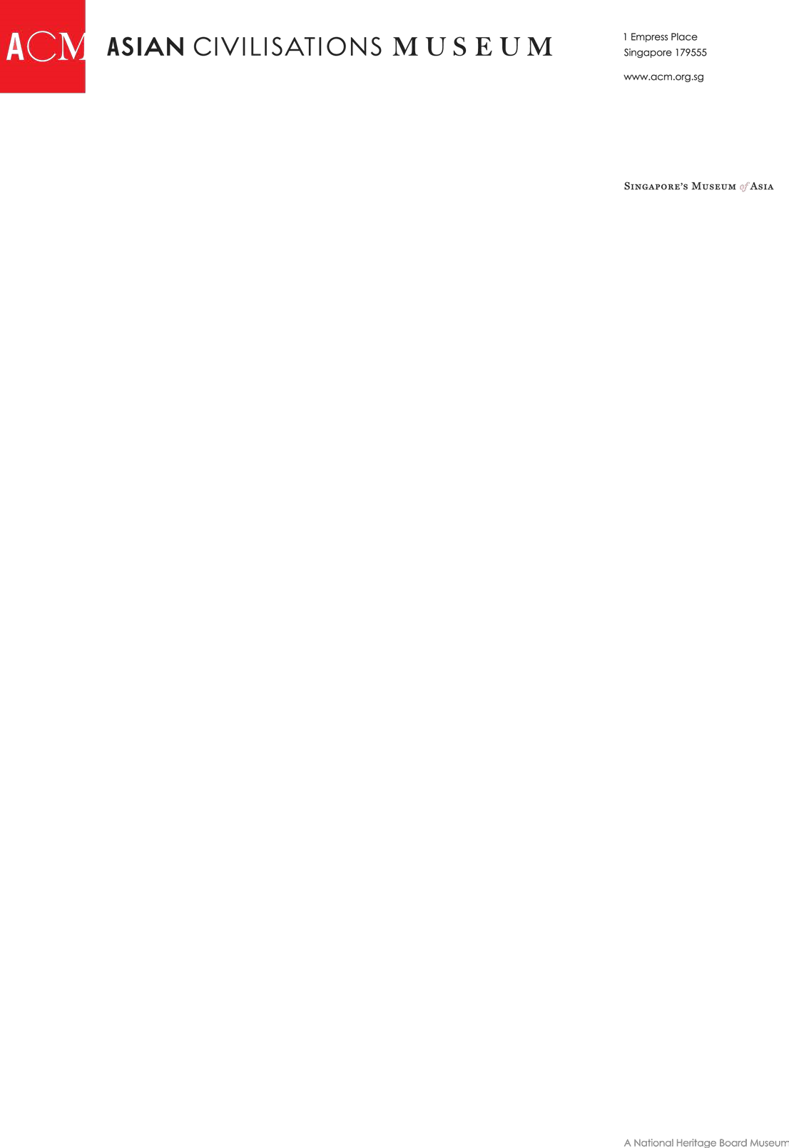

**DONATION FORM**

I/we would like to donate

*(*

*Donations are eligible for a tax deduction 2.5 times in value and they will be matched dollar-for-dollar.)*

Name of donor/company

Address

NRIC / Company registration number

Name on the credit

card

Credit Card type

VISA / MASTERCARD / AMERICAN EXPRESS

Credit card number

Credit c

ard CVV

(3

-

digit numbers behind the card)

Card expiry date (MM/YYYY)

Contact number

Email

Alternatively, you may mail your cheque with this form to Asian Civilisations Museum, 1 Empress Place,

Singapore 179555. Please make cheque payable to “Asian Civilisations Museum”.

For electronic banking transfer, please refer to the following:

Beneficiary Name: National Heritage Fund

Bank account: 003-900772-8

Currency: SGD

Bank code: 7171

Branch code: 003

Swift code: DBSSSGSG

Bank name: DBS Bank Ltd

BRANCH: Marina Bay Financial Centre

Bank Address: 12 Marina Boulevard, DBS Asia Central, Marina Bay Financial Centre Tower 3, Singapore 018982

For enquiries and further information, please email [SupportACM@nhb.gov.sg](mailto:SupportACM@nhb.gov.sg).